**ACKNOWLEDGEMENT**

The Satisfactory that accompanies the successful completion of a project would be incomplete without the people who made it possible. Their constant guidance and encouragement crowned our efforts with success.

We are very thankful to the project coordinator of **Prof**. **Dharmendra**  **Sir** of Harivandana College, who has provided us a lot of support & guidance from the beginning to the end of the project development.

We express our profound thanks to **Prof. Rathod Sir** , Head of the Department of Computer Engineering, Harivandana College of Rajkot. We would like to thank them for their continuous support and encouragement.

Last but not the least, our appreciable also goes to all staff members of Computer Engineering Department and to our fellow classmates who directly or indirectly helped us.

We take this opportunity to thank Harivandana College, Rajkot for giving us opportunity to do this project. We acknowledgement all our friends for their innumerable guidelines and suggestions. We also thank all the staff members and the Mr. Ronak Sir Rajkot for their valuable help and co-operation. We thank all of you once again.

**Project Title :** **Food Adda App Using Android & MySQL**

Submitted in the partial fulfillment of Project in

Bachelor Of Computer Application

( Semester – VI )

-: Submitted To :-

Department Of Computer Science Harivandana College, Rajkot.

-: Affiliated To :-

Saurashtra University, Rajkot

-: Submitted By :-

Name :- Prathvik A. Sankaliya

Enroll no :- 003203191777

Phone no:- 9723816724

-: Under the Guidance of :-

Prof. Ashwin Sir Rathod (Professor & Head)

Prof. Dharmendra Sir Ambani (Lecturer & Project in-charge)

Prof. Ronak Sir Goda (Lecturer)

-: Developed At :-

**Harivandana College Rajkot**



**LIST OF FIGURES**

|  |  |  |
| --- | --- | --- |
| **Figure No.** | **Figure Description** | Page No. |
| 1 | Use case diagram | 29 |
| 2 | Data Flow Diagram | 30 |
| 3 | ER-Diagram | 31 |
|  |  |  |

**LIST OF TABLES**

|  |  |  |
| --- | --- | --- |
| **Table No.** | **Name of Table** | **Page no.** |
| 1 | Project Development Model | 23 |
| 2 | Project plan | 24 |
| 3 | Schedule Representation | 25 |
|  |  |  |

* **Notation and Naming Convention**
* **Use case** :

|  |
| --- |
| **Sys tem** |

UseCase

1

System boundary Actor Usecase

-end1

*

*

-end2

Communication Link

* **Class Diagram** :

-End1

|  |
| --- |
|  |
|  |
|  |

-End2

Class Relationship Generalization

*

*

* **System activity diagram :**

Active Sate State Initial State

Final State control flow Conditional state

* **Sequence Diagram :**

Object line Activation message transition

* + **Flow chart:**

Process decision Transaction

Data manual input

* + **Data flow Diagram:**

Process

Name

Data Transfer

Database Process

|  |
| --- |
|  |

External Interface

**TABLE OF CONTENTS**

Acknowledgement **0**

**TABLES**

1. List of Figures **3**
2. List of Tables **4**

**NOTATIONS & ABBREVATIONS** **5**

1. **INTRODUCTION**  **10**

1.1Project Summary

* 1. Objective/aim/vision
  2. Scope
  3. Modules
  4. Project Boundary
  5. Duration

1. **LITERATURE SURVEY 15** 
   1. What Is Android Development?
   2. XML Overview
   3. Java Overview
   4. Android Overview
   5. MYSQL Overview
   6. Analysis
2. **PROJECT MANAGEMENT 21**
   1. Project Planning and Scheduling
      1. Project development Model
      2. .Project plan
      3. Schedule Representation

1. **REQUIREMENT SPECIFICATION 26** 
   1. Hardware Requirements
   2. Software Requirements

1. **SYSTEM DESIGN 28** 5.1 Basic Flow of System
   * 1. Use Case Diagram
     2. Data Flow Diagram

5.2 System Procedural Design

* + 1. E-R diagram

1. **IMPLEMENTATION 32**
2. **TESTING 53**

1. **FUTURE WORK 57**

1. **CONCLUSION 59**
2. **REFERENCES 61**

1

INTRODUCTION

* 1. **project Summary :**
  + An online Food Adda App projects that acts as a central database containing various Food Item in stock along with their Food name, quantity , food Price and images. This project is a Application that acts as a central Food-Adda app .
  + This app project is developed using android and mysql as a back-end. The sql database stores various food related details. A user visiting the app can see a wide range of foods arranged in respective categories and sub-categories. The user may select desired food or buy from the food-adda.
  + The user may even search for specific categories on the application. Once the user selects a food category , he then has to watch subcategory in a page and the details is open for the user. The software has the following three main components.
  + It gives the facility to the Quantity , Add to cart , User Details , Buy Food etc…
  + The application has the following three main components:-

1. Implement of new user to register at buy a food.

2. Implement user to choose any food using categories & sub-categories.

3. Implement the user to buy & Check the food details.

The Application implemented using Java as the programming language.

* 1. **Objective/aim/vision :**
* **Reasons:**
* For the project, we reason to provide an online Fast Food Environment for Peoples. The online Food will contain Details, Add to cart, any Food like fast food be available into app. Many peoples find food too expensive to buy .This online App provides a solution to this. It will provide a service in which people can buy foods online without any treble. They do need to register with the app in check the details about food.
* **Benefits:**
* Different types of Fast Foods.
* Divided in main categories and sub-categories.
* Add to cart and Buy Food easily and quickly by one click.
* All Foods small description available.
* All Foods images show the user.
* Quick response the all Activities.
* Easy navigate the categories.
* Provide rating of most favorite Food.
* **Goals & Objectives :**

• This app aims at reducing human effort & time of working hours.

• The main objective of this app is that any peoples of this app user can access from anywhere.

• This app is user friendly & easy to use for people.

• It provides fast & efficient way of solving the food problems.

* 1. **Scope :**
* **Language Scope :**
* Language use – Java, HTML, CSS, PHP, JAVASCRIPT, BOOTSTRAP, MySQL Connectivity.
* **Project Scope :**
* The scope of the project is defining what will and will not be supported by the app. This app will enable servers to manage

accounts: upload photos, fill out and submit foods and including short text descriptions, as well as register for add to cart foods .

* It’s provide the faster Showing Foods.
* Add , update And Delete the Foods and categories quickly.
* Our team provide security and manage bugs and errors.
  1. **Modules:**

The site will contain the following features:

* Register One time
* Different Categories & Subcategories provide.
* Add To Cart Functionality.
* Online Show the Foods.
* Buy the Food Any Time.
  1. **Project Boundary:**
* XAMMP Web Server.
* MySQL

**1.6 Duration:**

In 12 weeks my website will be completed.

Analysis : 2 weeks

Design : 2 weeks

Coding : 6 weeks

Testing : 2 weeks

2

LITERATURE SURVEY

**2.1 What is Android development :**

**Android software development** is the process by which applications are created for devices running the [Android operating system](https://en.wikipedia.org/wiki/Android_(operating_system)). Google states that[[3]](https://en.wikipedia.org/wiki/Android_software_development#cite_note-Android_Dev_Fundamentals-3) "Android apps can be written using [Kotlin](https://en.wikipedia.org/wiki/Kotlin_(programming_language)), [Java](https://en.wikipedia.org/wiki/Java_(programming_language)), and [C++](https://en.wikipedia.org/wiki/C%2B%2B) languages" using the Android [software development kit](https://en.wikipedia.org/wiki/Software_development_kit) (SDK), while using other languages is also possible. All non-[Java virtual machine](https://en.wikipedia.org/wiki/Java_virtual_machine) (JVM) languages, such as [Go](https://en.wikipedia.org/wiki/Go_(programming_language)), [JavaScript](https://en.wikipedia.org/wiki/JavaScript), [C](https://en.wikipedia.org/wiki/C_(programming_language)), C++ or [assembly](https://en.wikipedia.org/wiki/Assembly_language), need the help of JVM language code, that may be supplied by tools, likely with restricted API support. Some programming languages and tools allow [cross-platform](https://en.wikipedia.org/wiki/Cross-platform) app support (i.e. for both Android and [iOS](https://en.wikipedia.org/wiki/IOS)).

**2.2 XML Overview :**

➢ XML stands for Extensible Markup Language.

➢ XML is a markup language much like HTML used to describe data. It is derived from Standard Generalized Markup Language(SMGL). Basically, the XML tags are not predefined in XML.

➢ We need to implement and define the tags in XML. XML tags define the data and used to store and organize data. It’s easily scalable and simple to develop.

➢ In Android, the XML is used to implement UI-related data, and it’s a lightweight markup language that doesn’t make layout heavy. XML only contains tags, while implementing they need to be just invoked.

➢ Basically in Android XML is used to implement the UI-related data. So understanding the core part of the UI interface with respect to XML is important

➢ The User Interface for an Android App is built as the hierarchy of main layouts, widgets. The layouts are ViewGroup objects or containers that control how the child view should be positioned on the screen

➢ Widgets here are view objects, such as Buttons and text boxes

**2.3 Java Overview :**

➢ Java is one of the most popular and widely used programming languages.

➢ Java has been one of the most popular programming languages for many years

➢ Java is Object Oriented. However, it is not considered as pure objectoriented as it provides support for primitive data types (like int, char, etc)

➢ Java is used in all kinds of applications like Mobile Applications (Android is Java-based), desktop applications, web applications, client-server applications, enterprise applications, and many more

**2.4 ANDROID Overview :**

➢ Android is the best-selling Operating System among various mobile platforms across the globe. Hundreds of millions of mobile devices are powered by Android in more than 190 countries of the world.

➢ It conquered around 75% of the global market share by the end of 2020, and this trend is growing bigger every other day.

➢ Android is an open source and Linux-based operating system for mobile devices such as smartphones and tablet computers. Android was developed by the Open Handset Alliance, led by Google, and other companies.

➢ Android offers a unified approach to application development for mobile devices which means developers need only develop for Android, and their applications should be able to run on different devices powered by Android.

➢ The first beta version of the Android Software Development Kit (SDK) was released by Google in 2007 where as the first commercial version, Android 1.0, was released in September 2008.

* Why Android Development?

* Cost-Effective Platform: - Easy access to tools and systems to Android developers. - The end devices and hardware are relatively less expensive. - Rare compatibility issues with every updated OS version.

* Quick and Easy to Develop: - The availability of the easy working model makes it so quick to develop apps.

**2.5 MYSQL Overview :**

* **MYSQL Database Management System :** 
  + MySQL, the most popular Open Source SQL database management system, is developed, distributed, and supported by MySQL.
  + MySQL is a commercial company, founded by the MySQL developers. It is a second generation Open Source Company that unites Open Source values and methodology with a successful business model.
  + The MySQL Web site ([http://www.mysql.com/)](http://www.mysql.com/) provides the latest information about MySQL software and MySQL.
  + The official way to pronounce “MySQL” is “My Ess Que Ell” (not “my sequel”), but we don't mind if you pronounce it as “my sequel” or in some other localized way.
* **MYSQL Features :** 
  + MySQL, the most popular Open Source SQL database management system, is developed, distributed, and supported by MySQL.
  + MySQL is a commercial company, founded by the MySQL developers. It is a second generation Open Source Company that unites Open Source values and methodology with a successful business model.
  + The MySQL Web site ([http://www.mysql.com/)](http://www.mysql.com/) provides the latest information about MySQL software and MySQL.
  + The official way to pronounce “MySQL” is “My Ess Que Ell” (not “my sequel”), but we don't mind if you pronounce it as “my sequel” or in some other localized way.

**2.7 Analysis :**

When I started My Project First of all I had seen Food Store App Like

* <https://play.google.com/store/apps/details?id=in.swiggy.android>
* <https://play.google.com/store/apps/details?id=com.application.zomato>

etc. And seen their Facility which they provide

* Then I collected the Information about How Actual Food Store App work and then I collect information which i want for my App.

I have given following facilities in My App.

* **Client Side :**

* Register At One Time Only
* Profile manage
* Food Categories & Subcategories
* Rating Food
* Delivery Free or Paid
* Food Quantity
* Buy & Online Payment on FoodAdda
* **Admin Side :**

* Dashboard
* Login & Logout
* Show all Tables
* Add Category , Update Category , Delete Category
* Add User
* Add Foods and Add Menu Items

**3**

**PROJECT**

**MANAGEMENT**

**3.1 Project Planning and Scheduling**

**3.1.1 Project development Model**

* **Software Development Process : Waterfall Model**

In the waterfall model, a project progresses through an orderly sequence of steps from the initial software concept through system testing. The project holds a review at the end of each phase to determine whether it is ready to advance to the next phase - from requirements analysis to architectural design. If the review determines that the project isn't ready to move to the next phase, it stays in the current phase until it is ready.

The waterfall model is document driven, which means that the main work products that are carried from phase to phase are documents. In the pure waterfall model, the phases are also discontinuous - they do not overlap. The following shows how the pure waterfall lifecycle model progresses.

The pure waterfall model performs well for product cycles in which you have a stable product definition and when you're working with well-understood technical methodologies. In such cases, the waterfall model helps you to find errors in the early, low-cost stages of a project. It provides the requirement stability that developers crave. If you're building a well-defined maintenance release of an existing product or porting an existing product to a new plat. Form, a waterfall lifecycle might be the right choice for rapid development.

The pure waterfall model helps to minimize planning overhead because you can do all the planning up front. It doesn't provide tangible results in the form of software until the end of the lifecycle, but to someone

who is familiar with it, the documentation it generates provides meaningful progress throughout the lifecycle.

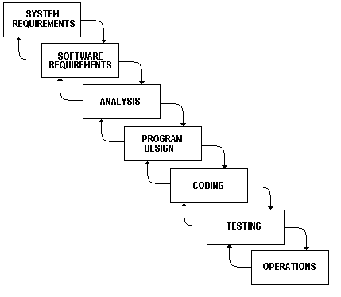

The waterfall model works well for projects that are well understood hut complex, because you can benefit from tackling complexity in an orderly way. It works well when quality requirements dominate cost and schedule requirements. Elimination of midstream changes eliminates a huge and common source of potential errors

**3.1.2 Project Plan:**

|  |  |  |
| --- | --- | --- |
| **System Analysis** | **Duration** | **Resource Requirement** |
| System Design and Documentation | 2 WEEKS | All |
| Actual Development | 2 WEEKS | All |
| Unit Testing | 1 WEEKS | All |
| Integrated of System | 1 WEEKS | All |
| Test case preparation | 2 WEEKS | All |
| System Testing | 2 WEEKS | All |
| Bug Fixing | 1 WEEKS | All |

**3.1.3 Schedule Representation:**

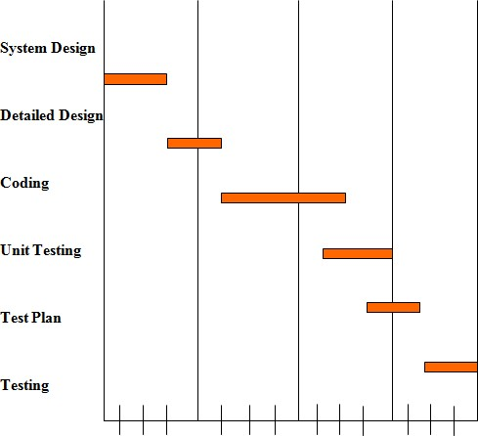

**4**

**Requirements**

**Specification**

**4.1** HARDWARE REQUIREMENTS :

* Intel i3 7th generation And Above
* Minimum 100 GB Hard disk
* Minimum 4 GB RAM
* Mouse, Keyboard
* 4x CR-ROM drive OR USB port

**4.2 SOFTWARE REQUIREMENTS :**

* Ubuntu 18.04LTS, Window 10 ,7
* Xamp web server latest version or wamp server
* Android Studio
* PHP 5.6.3
* MySQL 5.5.32
* Microsoft word
* Web Browser :
  + Mozilla Fire Fox & Google Chrome latest version

**5**

**SYSTEM**

**DESIGN**

**5.1 Basic Flow of System**

* **5.1.1 Use Case Diagram**

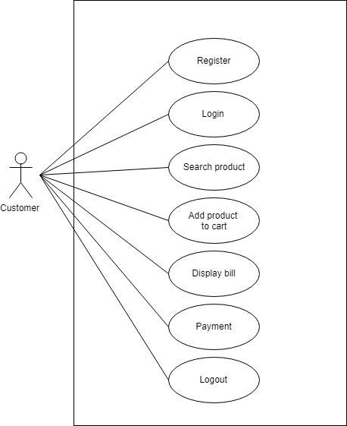

**5.1.2 Data flow diagram:**

Data Flow Diagrams show the flow of data from external entities into the system, and from one process to another within the system. There are four symbols for drawing a DFD:

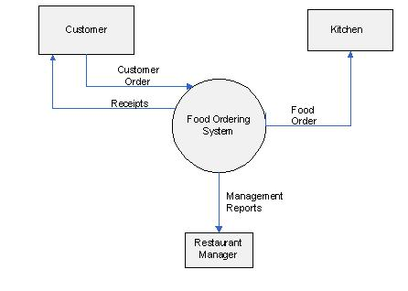

**5.2 System Procedural Design** :

* **5.2.1 Context Diagram**

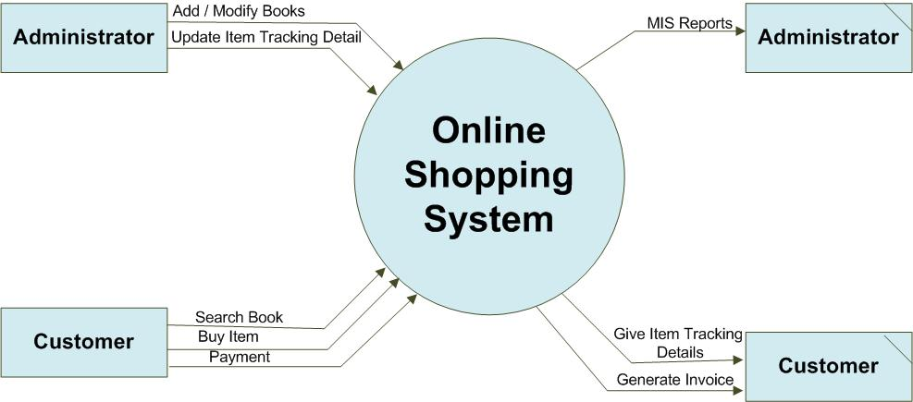

**6**

**IMPLEMENTATION**

* **addcart:**

|  |  |  |  |  |
| --- | --- | --- | --- | --- |
| Table Name | | addcart | | |
| Description | | This table is used to maintain and store the information related to add Cart. | | |
| Primary Keys | | id | | |
| Key | Field Name | Type | Size | Constraints |
| * | id | Integer | 25 | Primary Key |
|  | user_id | Integer | 40 | Not Null |
|  | Quantity | Integer | 60 | Not Null |
|  | Total_price | Integer | 60 | Not Null |
|  | Foodname | Varchar | 60 | Not Null |
|  | Food_img | Varchar | 60 | Not Null |
|  | date | Varchar | 60 | Not Null |

* **user_detail:**

|  |  |  |  |  |
| --- | --- | --- | --- | --- |
| Table Name | | User_detail | | |
| Description | | This table is used to maintain and store the information related to user detail. | | |
| Primary Keys | | id | | |
| Key | Field Name | Type | Size | Constraints |
| * | id | Integer | 25 | Primary Key |
|  | name | Varchar | 30 | Not Null |
|  | email | Varchar | 30 | Not Null |
|  | phone | Varchar | 30 | Not Null |
|  | address | Varchar | 30 | Not Null |
|  | date | Varchar | 50 | Not Null |
|  | status | Integer | 25 | Not Null |

* **admin:**

|  |  |  |  |  |
| --- | --- | --- | --- | --- |
| Table Name | | admin | | |
| Description | | This table is used to maintain and store the information related to admin register. | | |
| Primary Keys | | id | | |
| Key | Field Name | Type | Size | Constraints |
| * | id | Integer | 25 | Primary Key |
|  | name | Varchar | 40 | Not Null |
|  | email | Varchar | 30 | Not Null |
|  | password | Varchar | 30 | Not Null |
|  | time | Varchar | 60 | Not Null |
|  | status | Integer | 40 | Not Null |

* **category:**

|  |  |  |  |  |
| --- | --- | --- | --- | --- |
| Table Name | | cat | | |
| Description | | This table is used to maintain and store the information related to Food Category. | | |
| Primary Keys | | id | | |
| Key | Field Name | Type | Size | Constraints |
| * | id | Integer | 60 | Primary Key |
|  | name | Varchar | 60 | Not Null |
|  | img | Varchar | 60 | Not Null |
|  | date | Varchar | 60 | Not Null |
|  | status | Integer | 60 | Not Null |

* **add Menu Items:**

|  |  |  |  |  |
| --- | --- | --- | --- | --- |
| Table Name | | itemmenu | | |
| Description | | This table is used to maintain and store the information related to add menu items. | | |
| Primary Keys | | id | | |
| Key | Field Name | Type | Size | Constraints |
| * | id | Integer | 60 | Primary Key |
|  | name | Varchar | 60 | Not Null |
|  | img | Varchar | 60 | Not Null |
|  | description | Varchar | 60 | Not Null |
|  | price | Integer | 60 | Not Null |
|  | rating | Varchar | 80 | Not Null |
|  | delivery | Varchar | 80 | Not Null |
|  | type | Varchar | 60 | Not Null |
|  | date | Varchar | 60 | Not Null |
|  | status | Integer | 60 | Not Null |

* **DataBase Structure (image)**

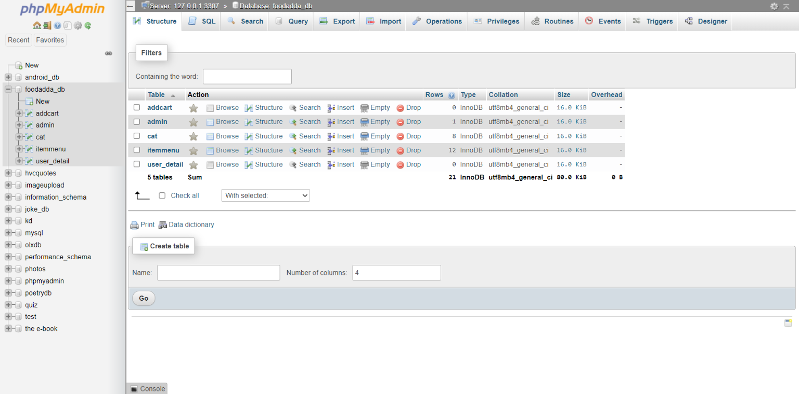

* **Application Layout:**
* **Splash Screen**

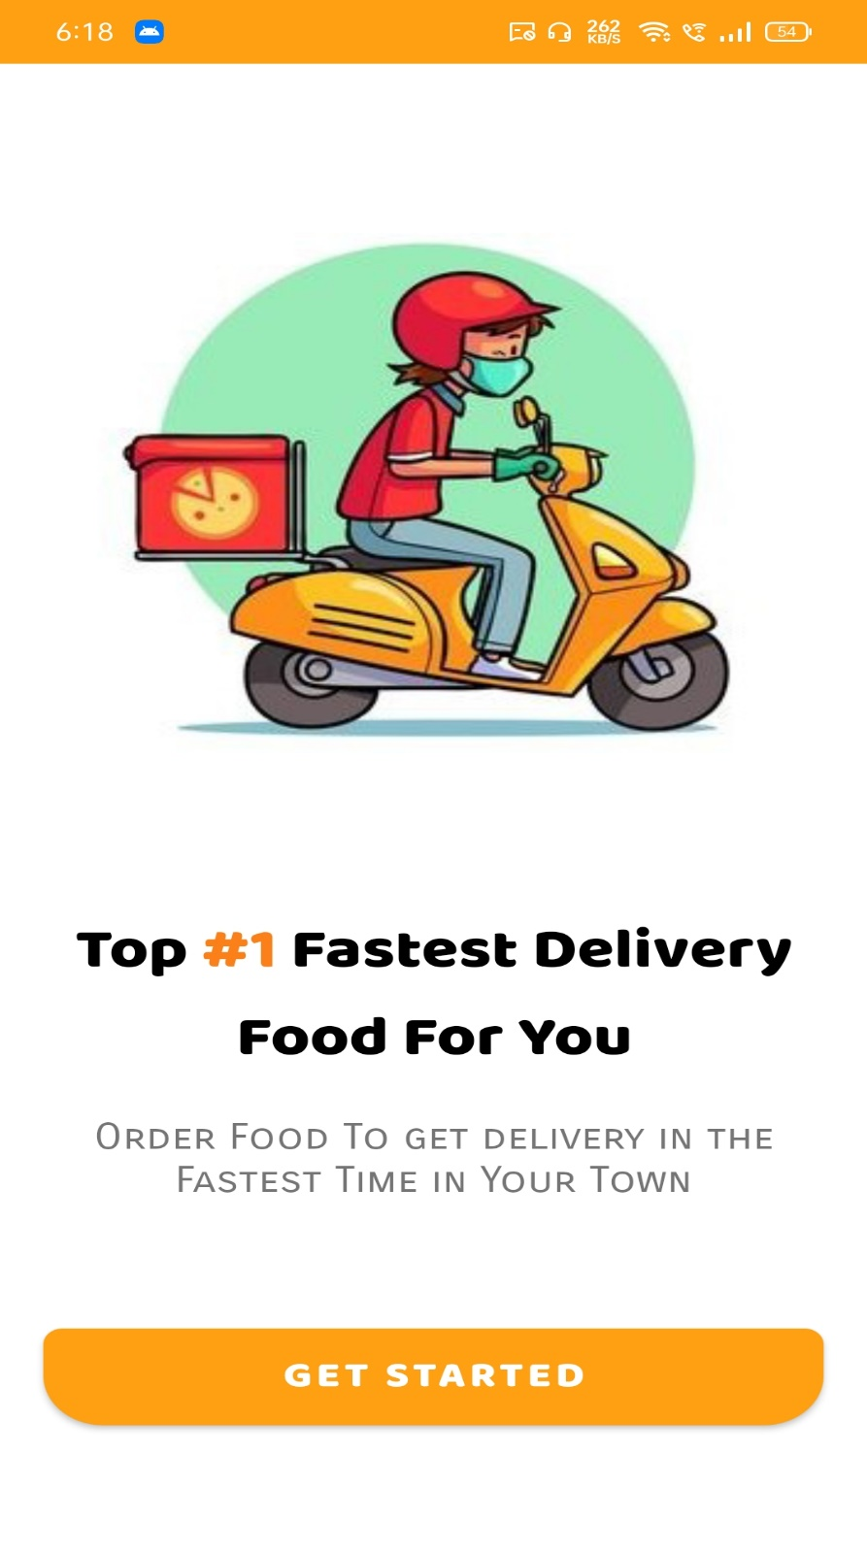

* **Home Screen:**

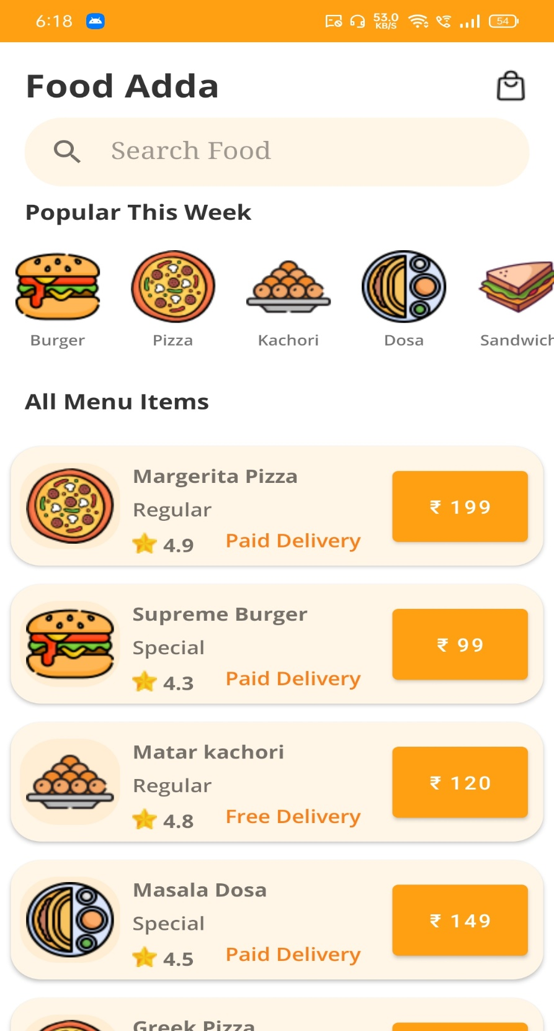

* **2nd Home Screen**

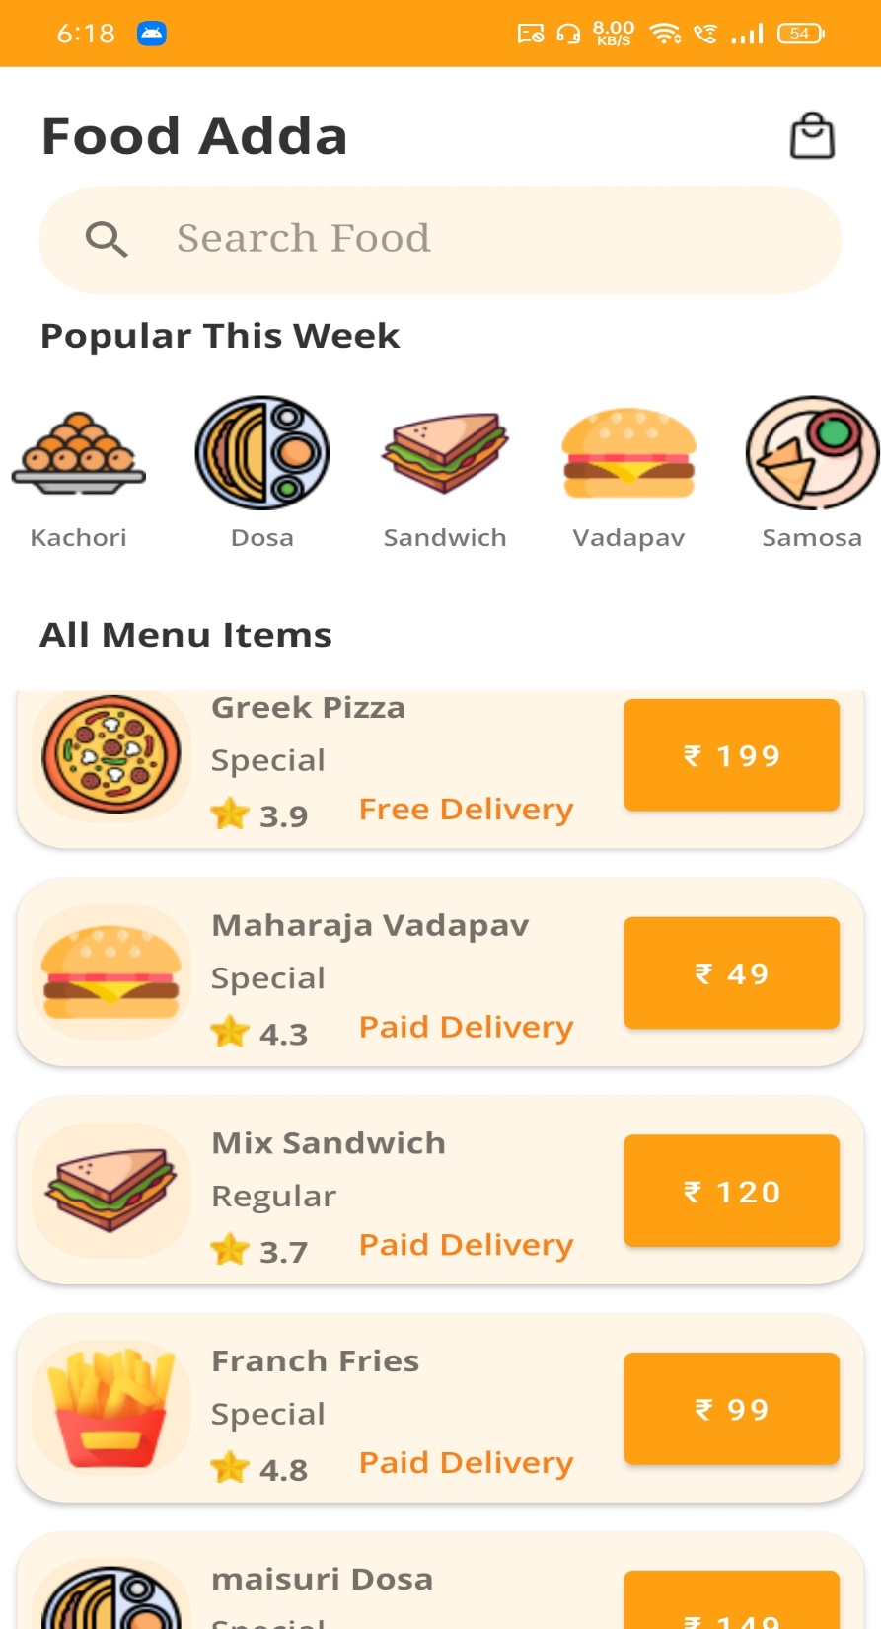

* **Food Details Screen:**

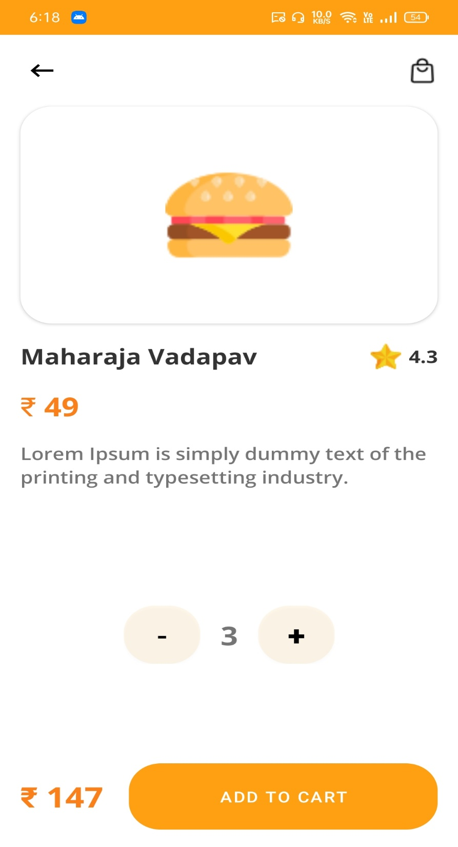

* **User Details:**

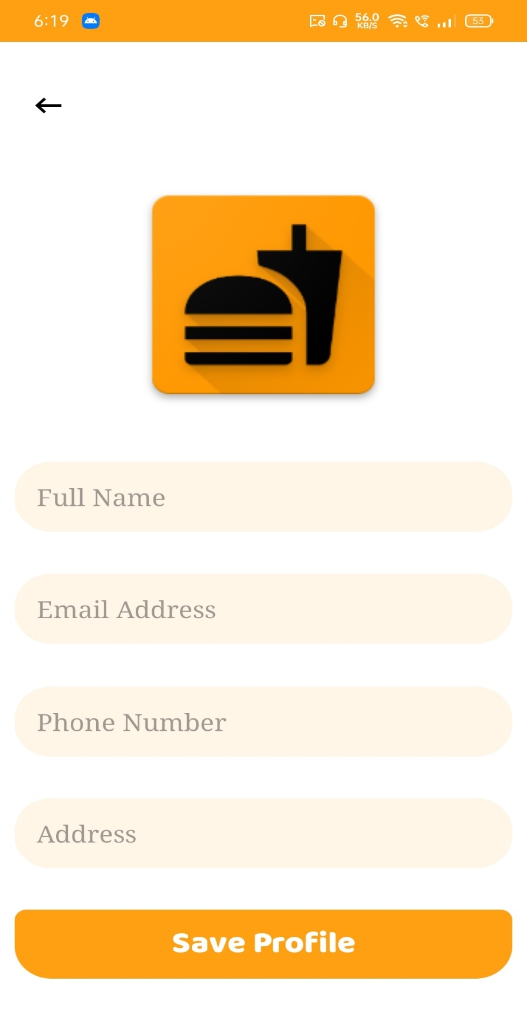

* **Fill-up Details:**

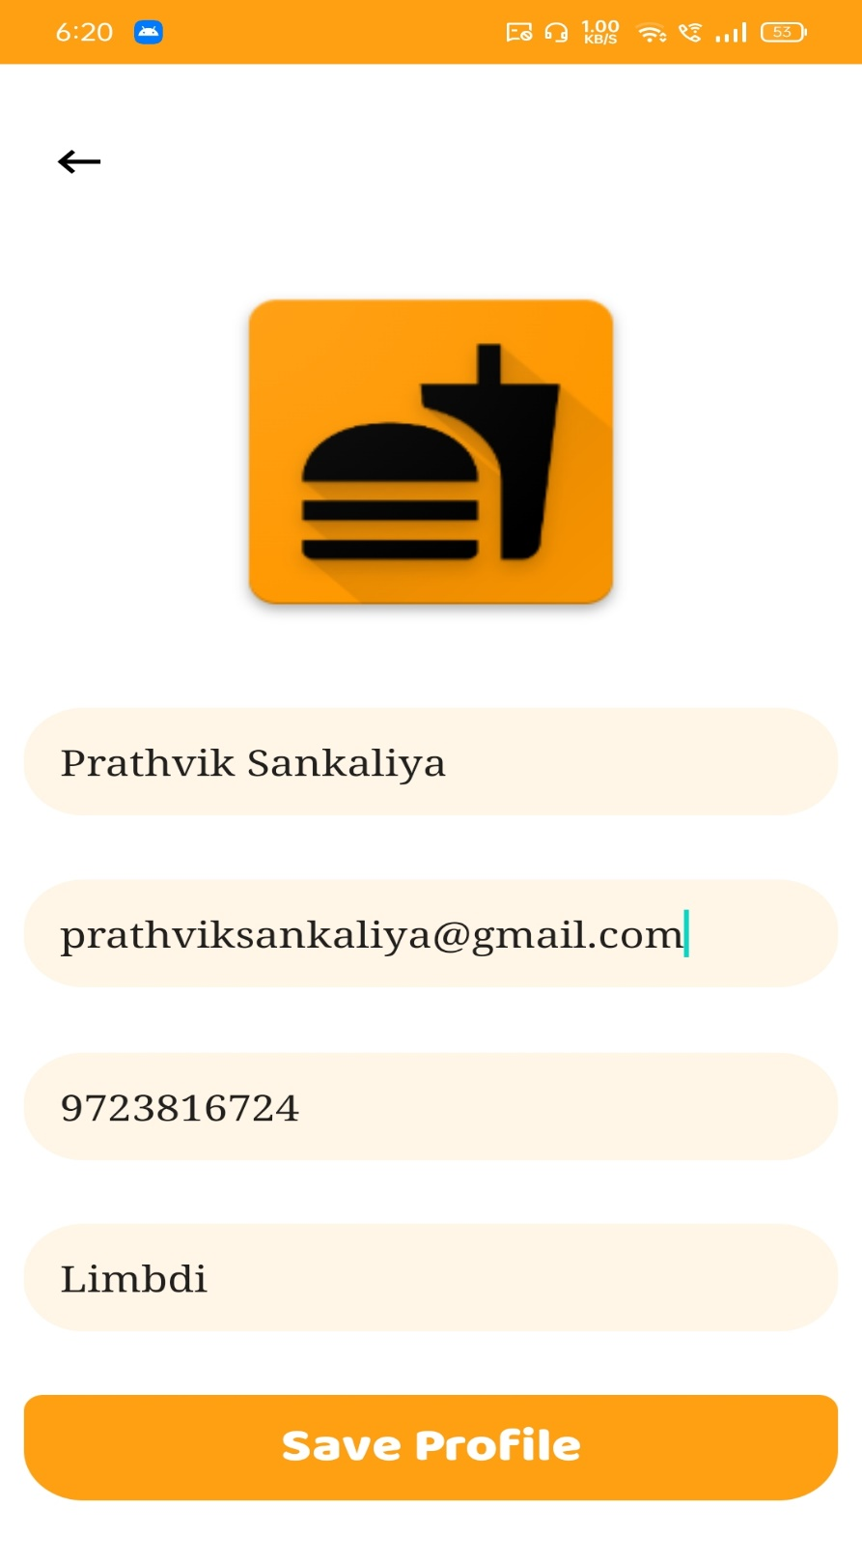

* **Add To Cart:**

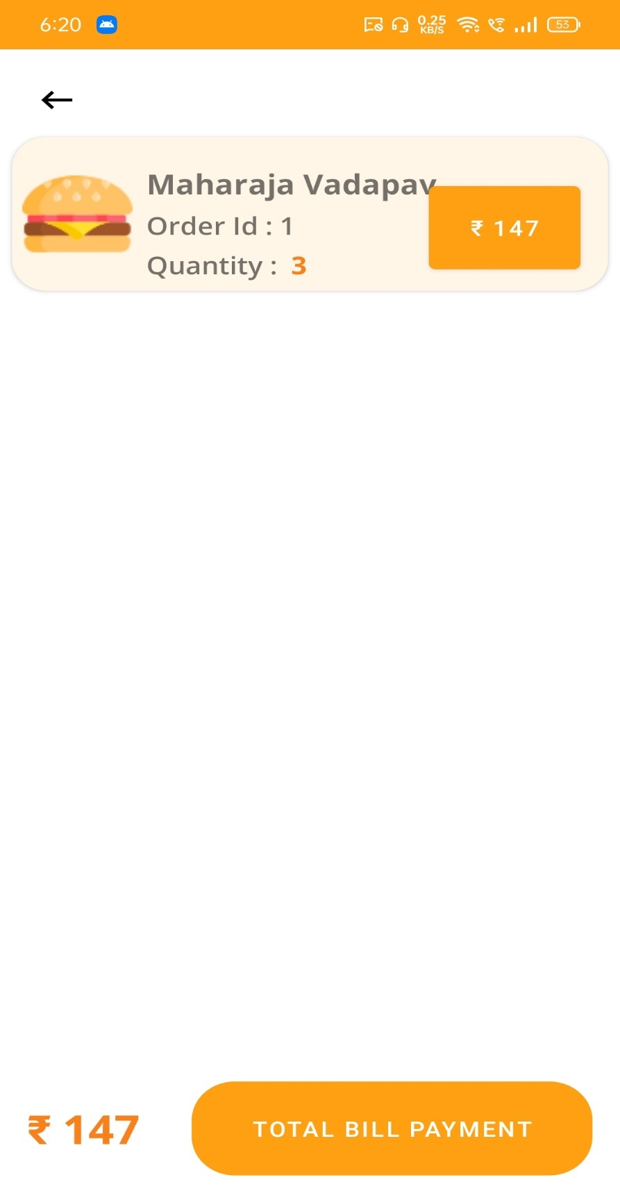

* **Update Screen:**

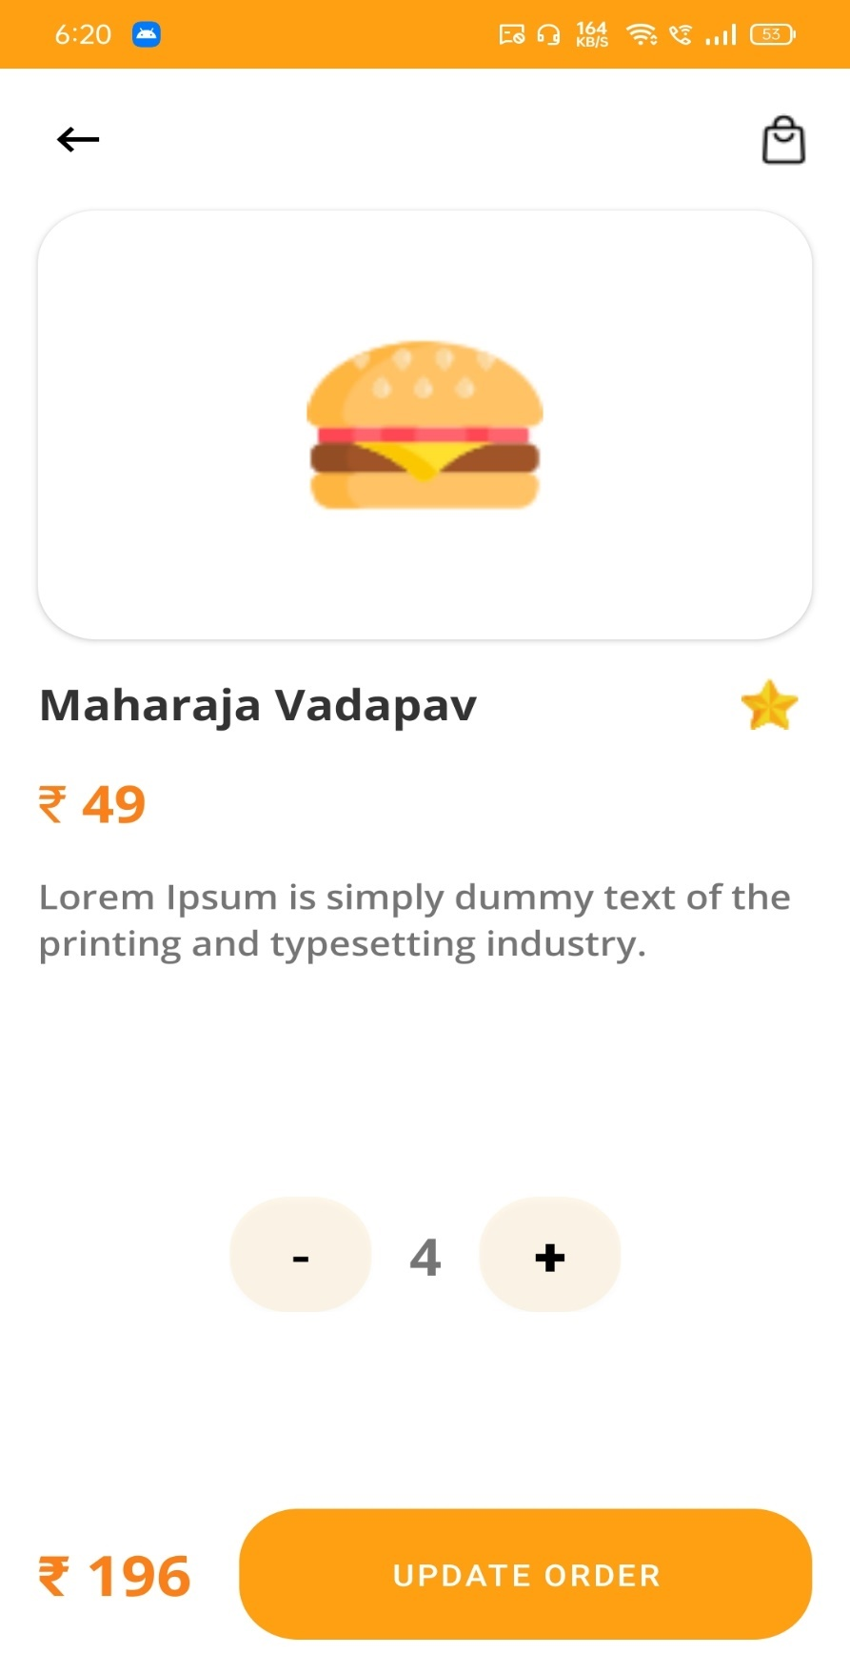

* **Payment Success Screen:**

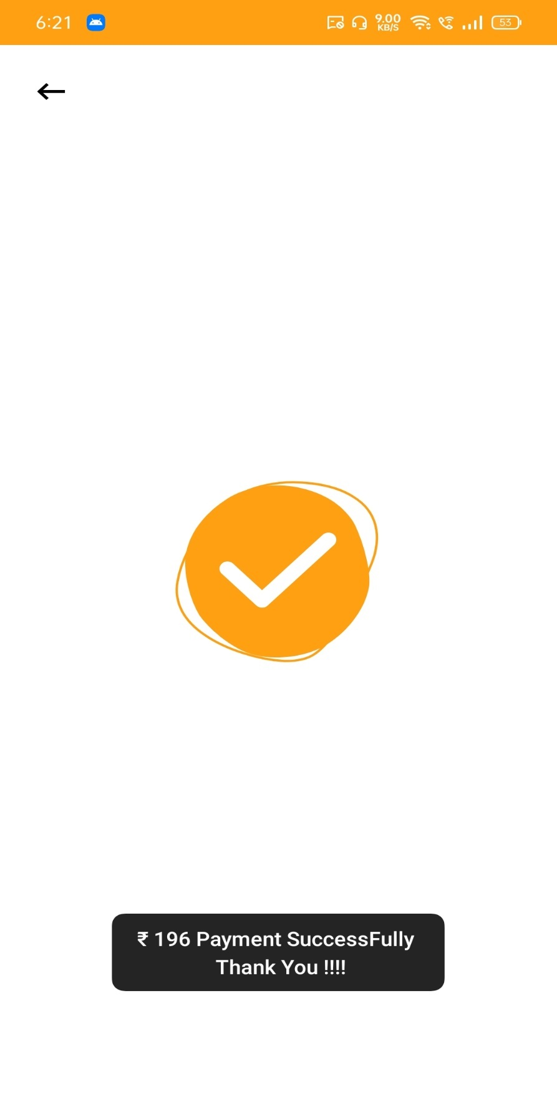

* **All Application Screen:**

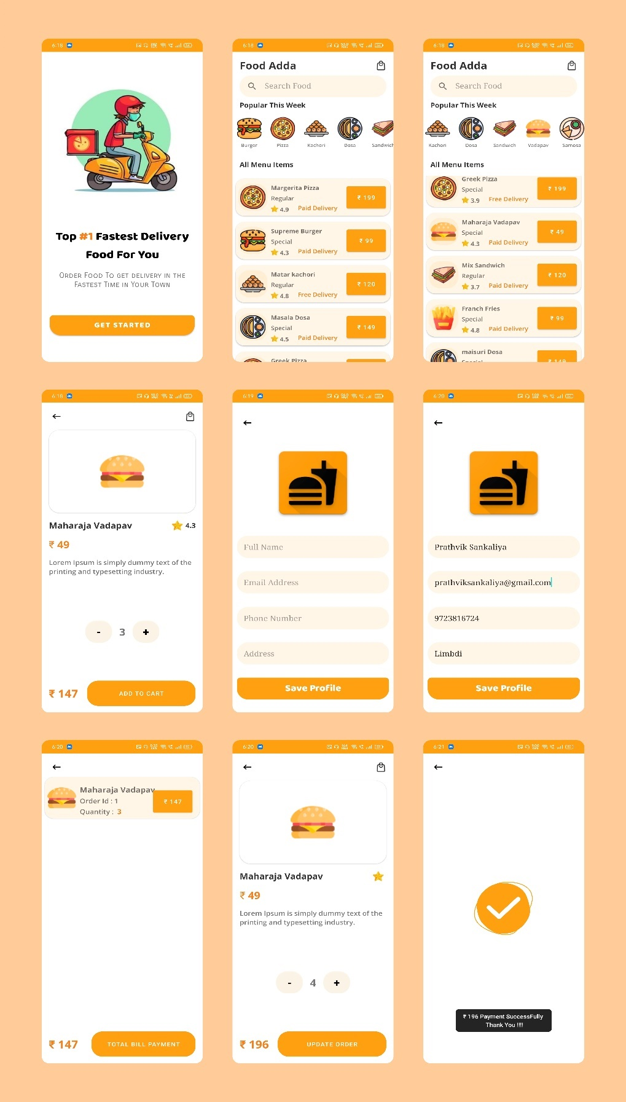

* **Admin Side :**
* **Register Page:**

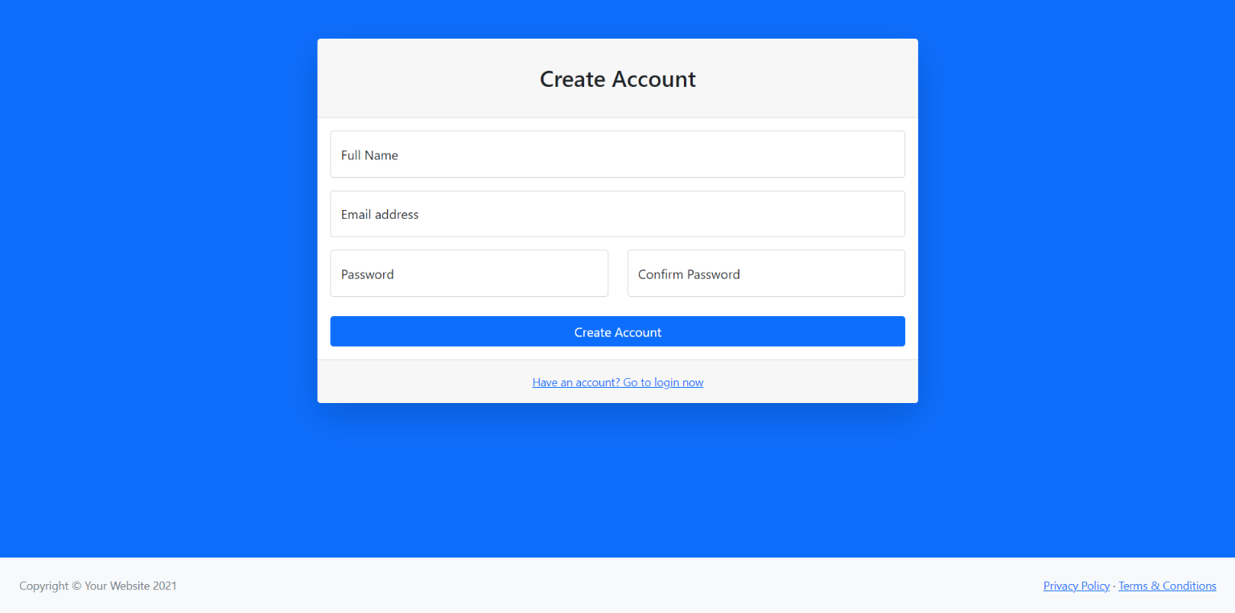

* **Login page :**

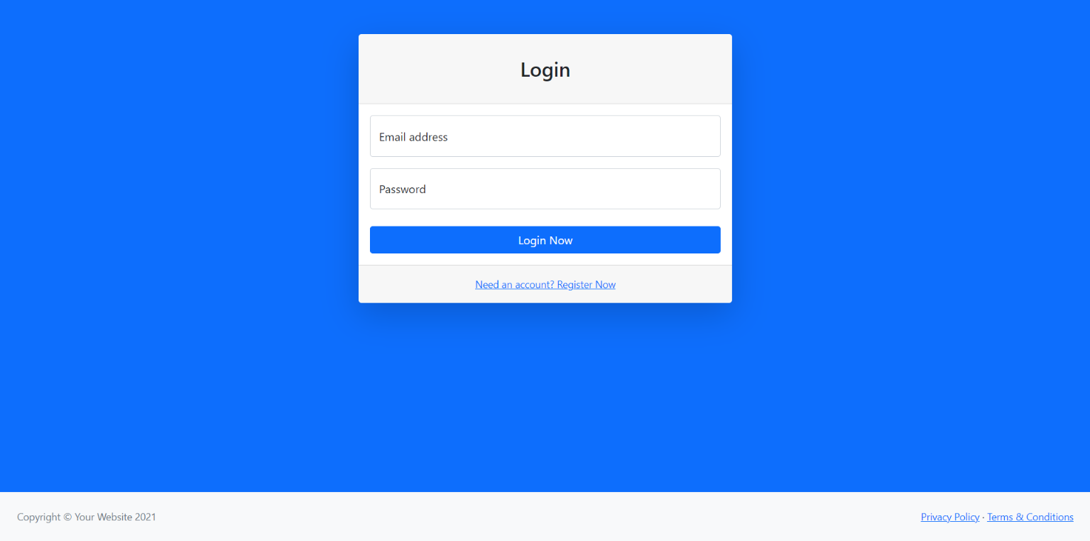

* **Home Page:**

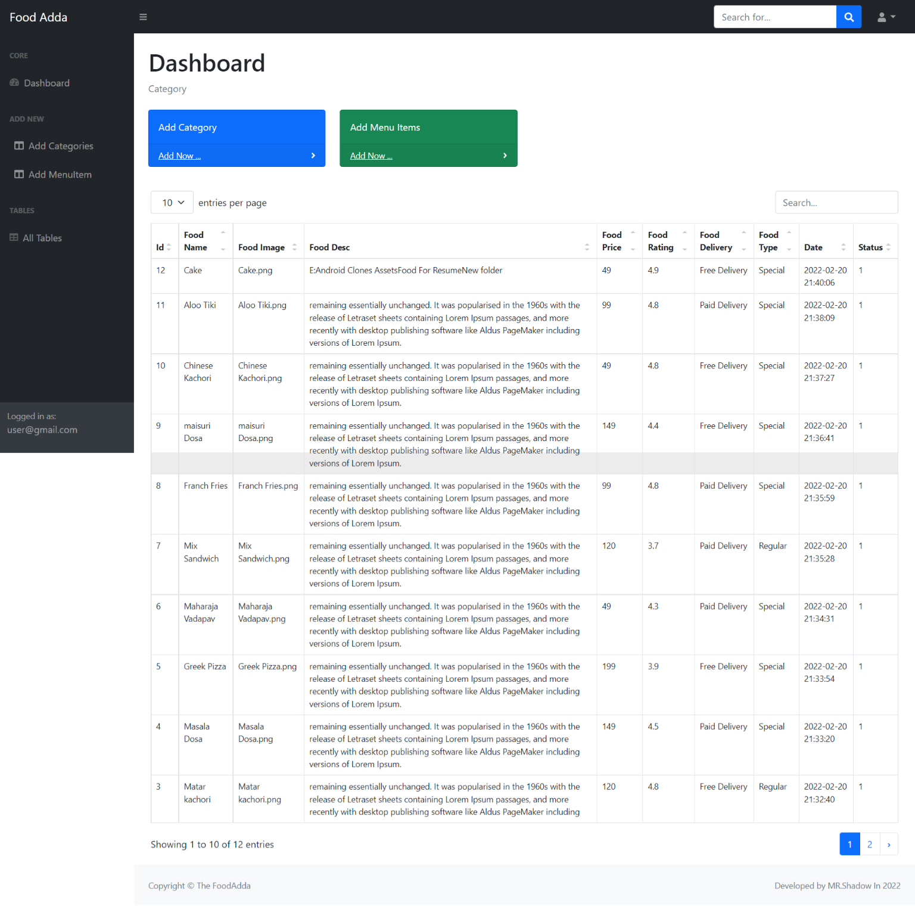

* **Add category Page:**

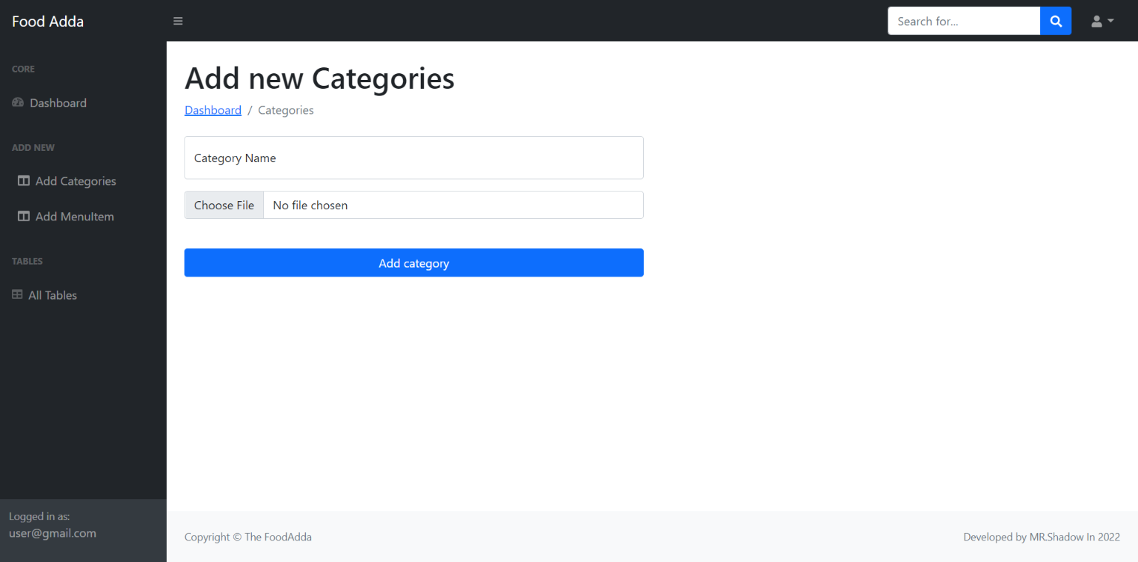

* **Add Subcategory Page:**

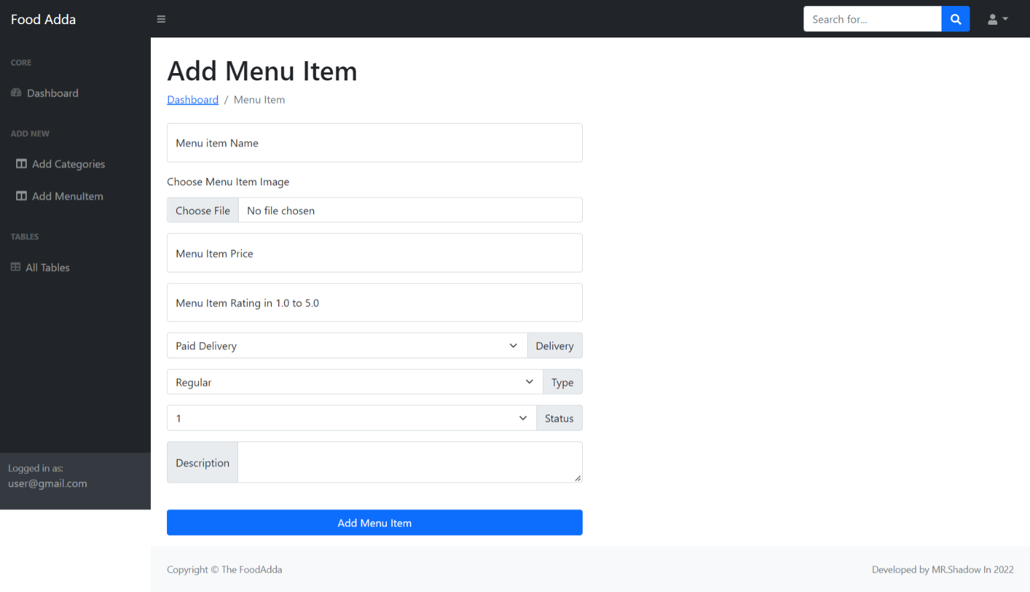

* **Update Category :**

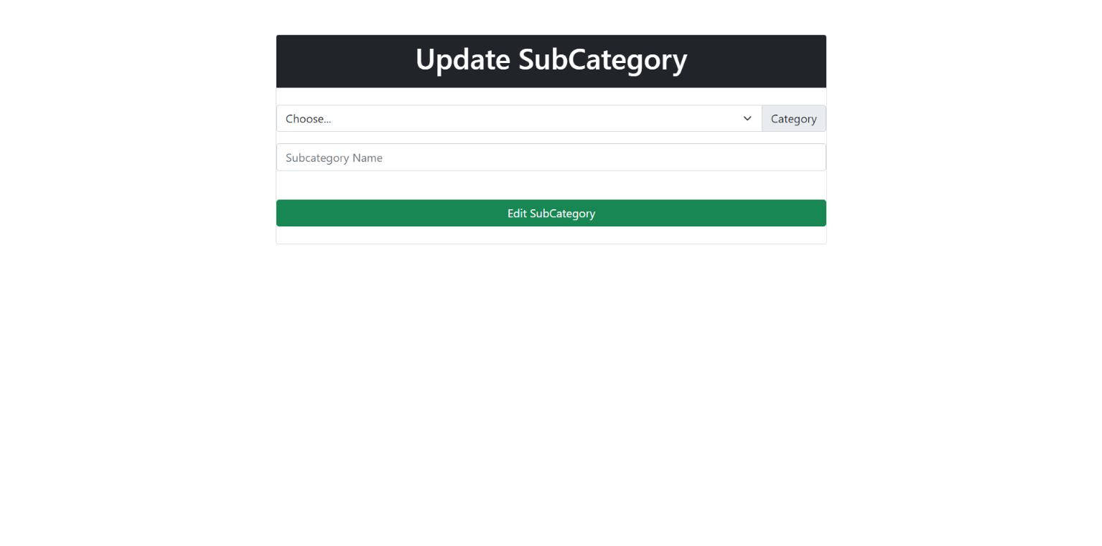

* **Show Tables Page:**

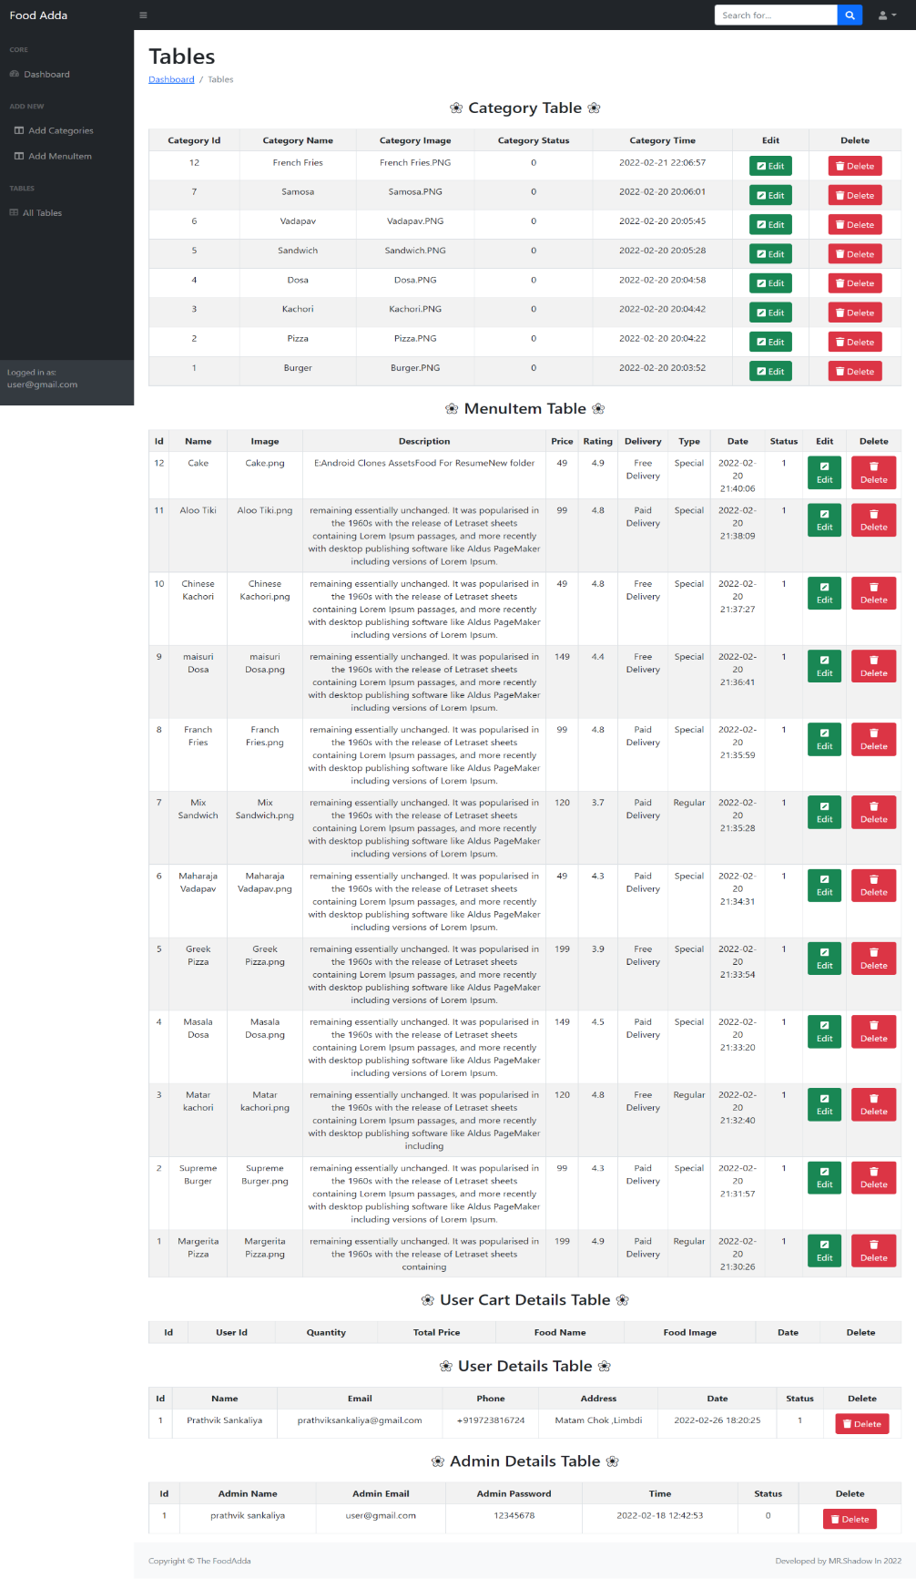

**7**

**Testing**

**7.1 TESTING**

*Testing*is one of the important steps in system development. Software Testing also provides an objective, independent view of the software to allow the business to appreciate and understand the risks at implementation of the software. Test techniques include, but are not limited to, the process of executing a program or application with the intent of finding [software bugs.](http://en.wikipedia.org/wiki/Software_bugs)

Software Testing can also be stated as the process of validating and verifying that a software program/application/product:

1. Meets the business and technical requirements that guided its design and development;
2. Works as expected; and
3. Can be implemented with the same characteristics.

Software Testing, depending on the testing method employed can be implemented at any time in the development process. However, most of the test effort occurs after the requirements have been defined and the coding process has been completed. As such, the methodology of the test is governed by the Software Development methodology adopted.

**7.2 TESTING LEVELS**

Tests are frequently grouped by where they are added in the software development

process, or by the level of specificity of the test.

* + 1. **Unit Testing**

*Unit Testing* refers to tests that verify the functionality of a specific section of code, usually at the function level. In an object-oriented environment, this is usually at the class level, and the minimal unit tests include the constructors and destructors.

These types of tests are usually written by developers as they work on code (white-box style), to ensure that the specific function is working as expected. One function might have multiple tests, to catch corner cases or other branches in the code. Unit testing alone cannot verify the functionality of a piece of software, but rather is used to assure that the building blocks the software uses work independently of each other. Unit testing is also called *Component Testing.*

* + 1. **Integration Testing**

*Integration Testing* is any type of software testing that seeks to verify the interfaces between components against a software design. Software components may be integrated in an iterative way or all together ("big bang"). Normally the former is considered a better practice since it allows interface issues to be localized more quickly and fixed.

[Integration Testing w](http://en.wikipedia.org/wiki/Integration_testing)orks to expose defects in the interfaces and interaction between integrated components (modules). Progressively larger groups of tested software components corresponding to elements of the architectural design are integrated and tested until the software works as a system.

* + 1. **System Testing**

[System Testing](http://en.wikipedia.org/wiki/System_testing) tests a completely integrated system to verify that it meets its requirements.

**7.3 TYPES OF TESTING**

* + 1. **FUNCTIONAL TESTING**

It is an approach to testing where the tests are derived from the program or component specification. The system is a black box whose behavior can only be determined by studying its inputs and the related outputs.

* + 1. **STRUCTURAL TESTING**

Structural testing is an approach to testing where the tests are derived from knowledge of the software‘s structure and implementation. This approach is sometimes called ‗white-box testing‘ to distinguish from black –box testing.

**8.**

**FUTURE WORK**

* We have done analysis of this entire system till now, and in future we will develop this system as per our analysis.

* In future this app will became very user-friendly and UI design will very effective.

* We will covert this app into website management so that any user can access our web anywhere through their computers .
* Payment , home delivery and Bank facilities will be available .

**9**

**CONCLUSION**

I have developed **“The Food Adda”**appin Readers to overcome the difficulties in managing the existing manual systems. The website has been designed effectively keeping in mind, the possible future enhancement and additional functionality; it has been designed to run in an efficient way.

The app is designed to be very user-friendly and interactive manner so that the user cannot find any difficulty while browsing the website. Thereby the proposed app, which is an economically, technically and operationally feasible system has overcome the deficiency that was present in the manual system.

**10**

**REFERENCES**

* This project was impossible to be a success without the support and help from the experience guide , the books and mainly the internet really prove it for us the “Information Highway”. Everything was really easy to find out on the internet.
* **WEBSITE :**
* [www.w3school.com](http://www.w3school.com/)
* <https://stackoverflow.com/>
* <https://github.com/>

#### Last But Not List :

Github ( Source Code) Link :

<https://github.com/prathviksankaliya/FoodAdda>